CCNA Beginner Guide
Cisco Packet Tracer: Basic LAN Setup, Ping, MAC Table, and ARP
Practice topology: PC0, Laptop0, WebServer, and Switch0
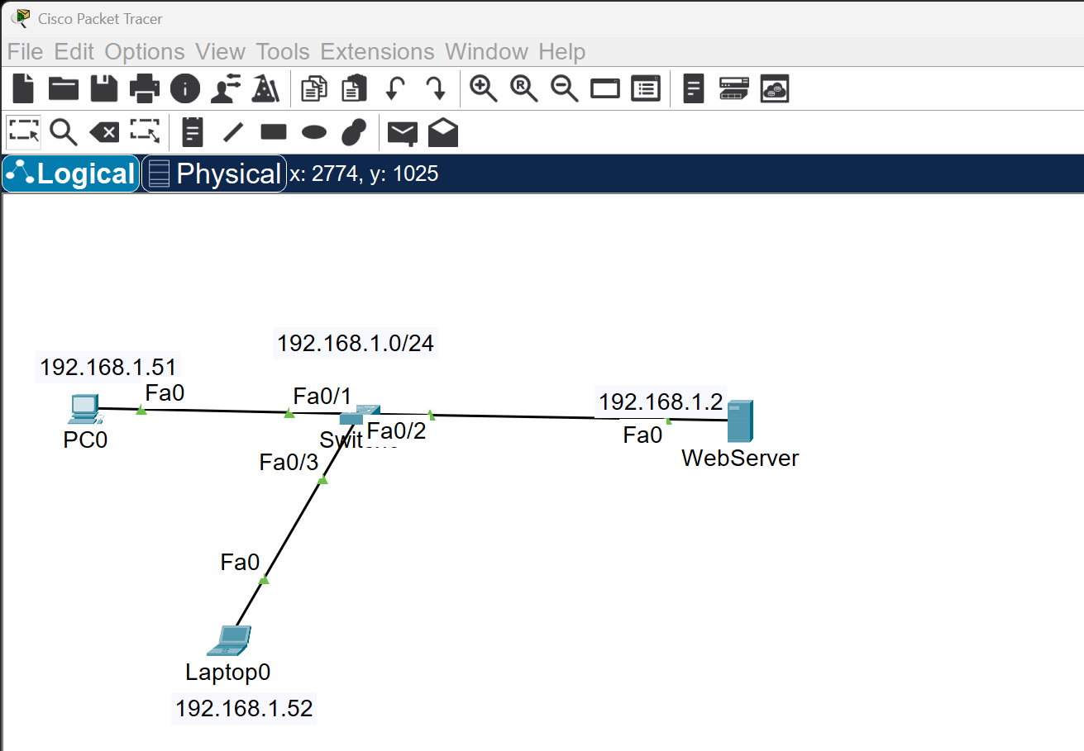
Figure 1. Example Packet Tracer topology used in this guide.
Goal. This guide shows a new CCNA learner how to assign IP addresses to end devices, configure a basic Layer 2 switch, test connectivity with ping, and view MAC address and ARP information in Cisco Packet Tracer.
Important note. In Packet Tracer, end devices such as PC0, Laptop0, and Server are usually configured from the Desktop tab, not with Cisco IOS configuration commands. Their Command Prompt is mainly for verification commands such as ipconfig, ping, and arp -a.

1. Addressing Plan
Device | IP Address | Subnet Mask | Notes
PC0 | 192.168.1.51 | 255.255.255.0 | Desktop > IP Configuration
Laptop0 | 192.168.1.52 | 255.255.255.0 | Desktop > IP Configuration
WebServer | 192.168.1.2 | 255.255.255.0 | Desktop > IP Configuration
Switch0 (optional mgmt) | 192.168.1.10 | 255.255.255.0 | Configured on VLAN 1

2. Set Up PC0, Laptop0, and WebServer
Because these are end devices, use the Packet Tracer GUI for IP addressing:
- PC0: Desktop > IP Configuration > IP Address 192.168.1.51, Subnet Mask 255.255.255.0
- Laptop0: Desktop > IP Configuration > IP Address 192.168.1.52, Subnet Mask 255.255.255.0
- WebServer: Desktop > IP Configuration > IP Address 192.168.1.2, Subnet Mask 255.255.255.0
Verification commands from each end device Command Prompt:
ipconfig
ipconfig /all
Example on PC0:
PC> ipconfig
IP Address.........: 192.168.1.51
Subnet Mask........: 255.255.255.0

3. Configure Switch0 from the CLI
This switch configuration is enough for a basic LAN. It sets a hostname, disables DNS lookup delays, makes FastEthernet ports access ports, and enables them.
enable
configure terminal
hostname Switch0
no ip domain-lookup
interface range fa0/1 - 3
switchport mode access
no shutdown
exit
end
write memory
Optional management IP on VLAN 1:
enable
configure terminal
interface vlan 1
ip address 192.168.1.10 255.255.255.0
no shutdown
exit
end
write memory
Useful switch verification commands:
show interfaces status
show mac address-table
show running-config

4. Test Connectivity with Ping
Open PC0, go to Desktop > Command Prompt, and run these tests. Ping PC0 to Laptop0:
ping 192.168.1.52
Ping PC0 to WebServer:
ping 192.168.1.2
If the IP addresses and cables are correct, both devices should reply successfully.

5. Check MAC Addresses
You can check MAC information on both the end devices and the switch. On PC0, Laptop0, or WebServer:
ipconfig /all
On Switch0:
show mac address-table
After traffic passes through the switch, the MAC address table should show learned MAC addresses on the connected ports.

6. Check ARP After Ping
ARP maps an IP address to a MAC address. The ARP table is usually empty or incomplete before devices communicate. After you ping another device, new ARP entries should appear. From PC0, send the pings first:
ping 192.168.1.52
ping 192.168.1.2
Then check ARP on PC0:
arp -a
Expected result: PC0 should learn an ARP entry for Laptop0 (192.168.1.52) and WebServer (192.168.1.2).

7. Quick Lab Checklist
- Assign 192.168.1.51/24 to PC0.
- Assign 192.168.1.52/24 to Laptop0.
- Assign 192.168.1.2/24 to WebServer.
- Configure Switch0 access ports and enable them.
- Ping Laptop0 from PC0.
- Ping WebServer from PC0.
- Use ipconfig /all to view local MAC information.
- Use show mac address-table on Switch0 to view learned MAC addresses.
- Use arp -a on PC0 after ping to view ARP entries.

8. Common Beginner Mistakes
- Using different subnets by mistake, such as 192.168.0.x on one device and 192.168.1.x on another.
- Forgetting to set the subnet mask to 255.255.255.0.
- Typing commands in the switch CLI while the cursor is still in user EXEC mode; use enable first.
- Trying to configure end-device IP addresses with Cisco IOS commands instead of the Desktop tab.
- Checking ARP or the MAC table before any traffic has been sent.

